My Cat Breed Web App

**This is a simple cat app that allows users to add cat breeds to a list and view corresponding cat images. When a cat breed is clicked, a larger image of the cat breed is displayed. The app is built using vanilla JavaScript and utilizes DOM manipulation to dynamically update the UI.**

Functionality:

**The cat app has the following functionality:**

Add Cat Breed:

**Users can enter a cat breed name in the input field and submit the form. The cat breed name is then appended to a list (OL) as a list item element, displaying the cat breed name in the list of cat breeds.**

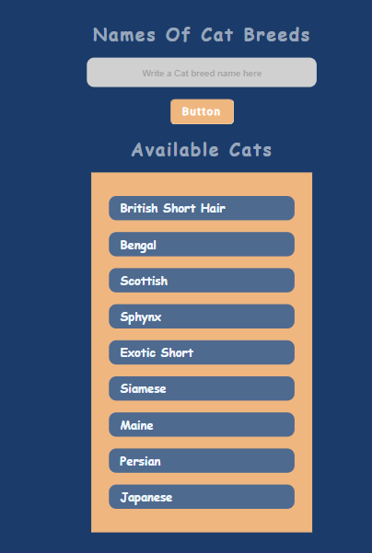

Display Cat Images:

**On the right-hand side of the app, there is a flex implementation that displays images of the exact cat breeds that are in the list. They are in thumbnail sizes. The images are dynamically appended to the flex container using JavaScript. Each image corresponds to a cat breed in the list of cat breeds.**

View Larger Cat Image:

**When a thumbnail image is clicked, a larger image of the same cat breed is displayed. The larger image is displayed in a separate container, and the display property of the list container is set to "none" to hide the list of cat breeds.**

**Close Larger Cat Image: When the close button is clicked, the larger image is hidden, and the display property of the list container is set back to "block" to display the list of cat breeds again.**

Usage

* **To use the cat app, follow these steps:**
* **Clone or download the repository from GitHub.**
* **Open the index.html file in a web browser.**
* **Enter a cat breed name in the input field and click the "Submit" button to add the cat breed to the list of cat breeds.**
* **Click on a thumbnail image of a cat breed to view a larger image of the same cat breed.**
* **Click the close button to close the larger image and display the list of cat breeds again.**

Technologies Used

*The cat app is built using the following technologies:*

* **Vanilla JavaScript: For DOM manipulation and handling user interactions.**
* **HTML: For the structure and layout of the app.**
* **CSS: For styling and positioning of elements.**

**Credits**

**The cat app is created by Vincent Nam (@iamvincentnam) as a project for Personal Learning. Special thanks to Colte Steel’s Web Development Bootcamp course on Udemy.**